[Rabia Rafiq F22BINFT1M01078]
Session: 2022 - 2026 |< information technology /The islamia university of bahawalpur>
[SMRT SOIL IRRIGATION SYSTEM]
Software Requirements Specification Document
17.12.2015

Revision History
Date | Description | Author | Comments
05-12-2025 | <Version 1> | RABIA RAFIQ | <First Revision>

Document Approval
The following Software Requirements Specification has been accepted and approved by the following:
Signature | Printed Name | Title | Date
 | SIR ABDUL KARIM NAWAZ | Supervisor, DIT | 05-12-2025

Table of Contents

1. Introduction 1
1.1 Purpose 1
1.2 Scope 1
1.3 Definitions, Acronyms, and Abbreviations. 1
1.4 References 1
1.5 Overview 2
2. The Overall Description 2
2.1 Product Perspective 2
2.1.1 Operations 2
2.1.2 Site Adaptation Requirements 3
2.2 Product Functions 3
2.3 User Characteristics 3
2.4 General Constraints 4
2.5 Assumptions and Dependencies 4
3. Specific Requirements 4
3.1 External Interface Requirements 5
3.1.1 System Interfaces 5
3.1.2 Interfaces 5
3.1.3 Hardware Interfaces 5
3.1.4 Software Interfaces 6
3.1.5 Communications Interfaces 6
3.2 Functional Requirements 6
3.2.1 <Functional Requirement or Feature #1> 6
3.2.2 <Functional Requirement or Feature #2> 7
3.3 Use Cases 7
3.3.1 Use Case #1 7
3.3.2 Use Case #2 7
3.4 Classes / Objects 7
3.4.1 <Class / Object #1> 7
3.4.2 <Class / Object #2> 7
3.5 Non-Functional Requirements 7
3.5.1 Performance 8
3.5.2 Reliability 8
3.5.3 Availability 8
3.5.4 Security 8
3.5.5 Maintainability 8
3.5.6 Portability 8
3.6 Inverse Requirements 8
3.7 Logical Database Requirements 8
3.8 Design Constraints 8
3.8.1 Standards Compliance 8
4. Analysis Models 9
4.1 Sequence Diagrams 9
4.2 Data Flow Diagrams (DFD) 9
4.3 State-Transition Diagrams (STD) 9
5. Supporting Information 9
Appendix A – Background Research on: 9
Appendix B – Data Dictionary 9

1. Introduction
Agriculture is one of the most important sectors in the world, and water is one of the most valuable natural resources for plant growth. Traditional irrigation methods depend heavily on farmer experience and manual effort, which may result in over-irrigation, under-irrigation, and unnecessary wastage of water. To overcome these challenges, the Smart Soil Irrigation System introduces automation and intelligence into irrigation practices. This system ensures that plants receive the required amount of water based on actual soil moisture conditions rather than estimation.
The Smart Soil Irrigation System uses a soil moisture sensor to continuously monitor the water content in soil. When the soil becomes dry, the sensor sends updated readings to the microcontroller. The microcontroller processes the data and automatically controls the water pump. Once the soil reaches a sufficient moisture level, the pump is turned OFF. Thus, the system provides accurate, real-time, condition-based irrigation to prevent both water deficiency and wastage.
To make the system more practical and advanced, wireless communication is integrated using a Wi-Fi module. This allows farmers to monitor the moisture status, pump condition, and system mode through a mobile or web interface, even when they are not physically present. Manual override control is also available, enabling users to turn ON/OFF the pump remotely with a single click.
This system runs on a main power supply or a battery. For long-term deployment in large farms or remote areas, the system can be integrated with solar panels, ensuring sustainable energy usage. The microcontroller is programmed using C/C++, which provides fast execution and compatibility with embedded hardware. This irrigation automation solution not only reduces human effort but also improves crop yield, saves water, reduces electricity consumption, and supports farmers in making their fields smarter and more productive.

1.1 Purpose
The purpose of this Software Requirements Specification (SRS) is to clearly define the complete set of functional, non-functional, hardware, and software requirements for the Smart Soil Irrigation System. The goals of this document are:
- To establish a mutual understanding between developers, supervisors, and stakeholders.
- To provide a solid foundation for the design, development, testing, deployment, and evaluation of the system.

To ensure that the system delivers:
  - Water efficiency through automatic irrigation control
  - Higher agricultural productivity
  - Remote monitoring and ease of use for farmers
  - Reduced human involvement for improved reliability

This document ensures clarity, correctness, and completeness before starting implementation.

1.2 Scope
This system enables continuous monitoring and intelligent watering in multiple real-world environments such as:
- Large agricultural farms
- Greenhouses and nurseries
- Home gardens and rooftop plants
- Parks and landscaped areas
The key capabilities of this system include:
- Automatic irrigation based on moisture levels
- Remote monitoring and control via the internet
- Live display of soil moisture percentage
- Pump ON/OFF automation with safety limits
- Battery or solar-powered operation
- Data logging for decision making
- User authentication for secure access

Benefits to users:
Benefit | Description
Water Conservation | Eliminates unnecessary watering
Higher Yield | Maintains optimal soil conditions
Low Labor | Reduces manual workload for farmers
Energy Savings | Solar implementation reduces electricity usage
Accessible Monitoring | Farmers can check conditions anytime from anywhere

1.3 Definitions, Acronyms, and Abbreviations.
Term | Description
- Smart Irrigation | Automatic supply of water based on real-time soil needs
- Sensor Calibration | Adjustment of sensor output to match actual soil conditions
- IoT | Internet of Things — devices connected to cloud for communication
- Relay Driver | Switching circuit used to operate AC water pump
- Threshold | Minimum required soil moisture for plant needs
- Auto Mode | System decides irrigation based on sensor readings
- Manual Mode | User fully controls irrigation from remote application
- ESP8266/ESP32 | Wi-Fi supported microcontroller boards
- Firmware | Embedded software running on microcontroller
- Cloud Server | Remote platform for data storage and access

1.4 References
These sources support the technical and theoretical background of the project:
- Arduino Microcontroller Documentation — official programming and pin-interface guidelines.
- Soil Moisture Sensor Datasheet — electrical characteristics and calibration methods.
- IoT-based Smart Irrigation Techniques — research publications and case studies.
- Wi-Fi Communication Protocol Standards — IEEE wireless network usage guidelines.
- Tutorials on relay interfacing with microcontrollers — electronic switching methodology.
- Solar energy system integration research for agricultural automation.

1.5 Overview
This SRS document is organized into structured sections:
- Section 1: Introduces the purpose, scope, and terminology of the system.
- Section 2: Describes the overall system perspective, product functions, constraints, and assumptions.
- Section 3: Contains detailed descriptions of functional requirements, hardware/software interfaces, use cases, performance parameters, and database needs.
- Additional diagrams (use-case, DFD, architecture, flowcharts) support technical design clarity.
This document acts as a blueprint to ensure the development of a reliable, efficient, secure, and user-friendly Smart Soil Irrigation System.

2. The Overall Description
The Smart Soil Irrigation System is an IoT-based embedded system designed to automate agricultural irrigation and provide remote monitoring capabilities. The system continuously senses the soil moisture level and operates a water pump based on real-time soil conditions. Unlike traditional irrigation where farmers must manually monitor and water crops, this system makes irrigation intelligent and automatic. The main components of the system include a soil moisture sensor, a microcontroller (Arduino with Wi-Fi module such as ESP8266), relay module, water pump, and optional solar power supply. The system uploads moisture values to a cloud platform which allows users to control irrigation from a mobile or web interface. This system is reliable, energy-efficient, and highly beneficial for farms located in remote areas.

2.1 Product Perspective
The Smart Soil Irrigation System is a stand-alone automation product that can also be expanded into larger IoT-based smart agriculture ecosystems. It is designed as a replacement and improvement over manual irrigation systems. The system uses data from the real environment (soil moisture sensor) and automatically controls the irrigation pump through programmed decision-making. By integrating Wi-Fi communication, the system becomes more interactive, allowing farmers to receive real-time information from anywhere.
This system includes the following modules:
Module | Description
Sensing Module | Soil Moisture Sensor monitors soil condition
Control Module | Microcontroller processes sensor input and triggers actions
Power Module | Battery or solar panel to power electronics and pump
Communication Module | Wi-Fi for cloud connectivity and remote monitoring
Actuation Module | Relay + Pump to control irrigation automatically

The product can be installed on small garden beds or extended across wide agricultural fields with additional sensors and pumps.

2.1.1 Operations
- The system performs its operations continuously through the following process:
- Soil Monitoring Phase
  - Soil moisture sensor collects humidity level every few seconds
  - The microcontroller interprets data and checks threshold values
- Decision-Making Phase
  - If soil moisture < threshold → Pump ON
  - If soil moisture ≥ required level → Pump OFF
  - Safety timer prevents long or unnecessary pump running
- Remote Monitoring Phase
  - Moisture level is uploaded to cloud
  - Farmer views data on mobile/web dashboard
  - Manual commands can override automatic mode
- Power Management Phase
  - System runs on DC supply or solar power
  - Low-power mode used during inactivity
  - This automated cycle ensures irrigation only when needed, improving water efficiency.

2.1.2 Site Adaptation Requirements

The system must be installed and adapted according to real agricultural or gardening conditions:
Requirement Category | Details
Environmental | Electronics must be protected from heat, dust, insects, and rain (IP-rated waterproof casing recommended)
Placement of Sensor | Sensor must be inserted 5–10 cm deep in soil for accurate readings
Pump Installation | Pump installed near water source with proper hose connections
Network Requirements | Wi-Fi coverage is required for cloud features; alternative GSM module can be used in remote areas
Power Requirements | Solar panels or rechargeable batteries preferred in rural areas to maintain continuous operation

Large farms may require multiple sensors for accurate moisture distribution feedback.

2.2 Product Functions
This system provides the following main functions:
Feature Category | Detailed Functionality | Benefit
Automatic Irrigation | Pump activation/deactivation based on soil dryness | Saves water & eliminates manual effort
Remote Monitoring | View live moisture percentage on mobile/web app | Farmer can monitor status anytime
Remote Manual Control | Command pump ON/OFF remotely | Full flexibility & convenience
Alert Notifications | Low moisture alerts sent to user | Prevents crop stress
Data Logging | Keeps history of moisture & pump events | Helps in farming decisions
Self-Protection | Pump timeout & fault detection | Ensures system safety
Solar Integration | Works independently off-grid | Useful in rural regions
These functions ensure optimal plant growth and resource management.
.

2.3 User Characteristics
User Type | Technical Knowledge | Responsibilities | Example User
Primary User | Low — Normal farmers / Gardeners | Checking moisture status, controlling pump | Farmer, Gardener
Secondary User | Medium — Basic electronics skill | System installation & maintenance | Technician
Technical/Developer User | High — Programming + Networking | Updating firmware, cloud settings | Engineer

2.4 General Constraints
Constraint Category | Impact on System
Sensor Accuracy Variation | Different soil types (clay, sand) affect readings → requires calibration
Climate & Weather Exposure | Electronics must survive heat, moisture, insects, dust
Power Supply Limitations | Pump requires high current → battery capacity must be large
Internet Connectivity | No Wi-Fi → Remote monitoring disabled, only Auto Mode active
Relay Load Capacity | Pump motor should not exceed rated current load
Component Lifespan | Harsh environments reduce durability of sensors and pump
.

2.5 Assumptions and Dependencies
Project Assumptions:
  - Moisture sensor is correctly calibrated with the crop’s soil type
  - Farmer/family has a smartphone to access control app
  - Wi-Fi network or alternative connectivity is available
  - Water source (tank/pipe) is functioning and always filled
  - System installed correctly according to provided guidelines
External Dependencies:
  - Quality and lifetime of external components (pump, pipes, sensors)
  - Cloud server uptime and security policies
  - Availability of sunlight for solar panel-based systems
  - Microcontroller firmware stability
  - If any dependency fails, irrigation performance reduces.

3. Specific Requirements
This section defines the complete system behavior for the Smart Soil Irrigation System. It includes interaction requirements, functional automation rules, user interaction, safety features, network behavior, and quality expectations for a fully deployable IoT agricultural solution.

The requirements are derived from:
- User needs
- Agricultural irrigation domain standards
- Environmental constraints
- Embedded system reliability concerns
- IoT communication behavior
- The SMART requirements below must be Specific, Measurable, Achievable, Relevant, and Testable.

3.1 External Interface Requirements

3.1.1 System Interfaces

The Smart Irrigation System must interact with the following subsystems:
Subsystem | Interaction Role | Dependency | Failure Handling
Soil Moisture Sensor | Measure soil humidity levels | Sensor integrity | Switch to default irrigation cycle if failure detected
Relay + Pump Unit | Performs irrigation | Power stability | Immediate shut-off on overload
Cloud Server | IoT communication | Internet connectivity | Auto local fallback logic
Mobile/Web App | Remote control & monitoring | Cloud success | Manual control disabled offline

Detailed Designs:
- Moisture sensor communicates through ADC to MCU using voltage output values converted to moisture percentage.
- Relay communicates using digital logic signals; pump uses inductive load, so protection diode is required.
- Cloud communication uses MQTT, optimized for machine-to-machine data.
- Why: To ensure safe, accurate, continuous communication between sensing → intelligence → action → monitoring flow.

3.1.2 Interfaces
The user interface must be designed for farmer-friendly usage:
UI Functional Requirements
- Live moisture display: “% Moisture”, “Soil Status: Dry / Optimal / Wet”
- Pump ON/OFF control button visible at all times
- Mode selects: Automatic / Manual
- Moisture threshold slider/input box (0–100%)
- Historical charts: hourly, daily, weekly trends
- Push notifications when system detects dryness for >180 seconds
- User profile: name, farm details, system ID
- Device health display: Wi-Fi strength, battery percentage (if solar)
UI Usability Requirements
- Click actions must not exceed 2 steps
- Font must be readable in sunlight
- Icons instead of text for low-literacy users
- Multilingual support (e.g., English, Urdu)
UI Safety Requirements
- Critical functions require confirmation pop-ups:
  - “Start Pump?” → YES/NO
- Auto logout after 10 min of inactivity
UI Accessibility
- Mobile responsive layout including low-brightness mode for night workers
Why:
Farmers often work in harsh outdoor conditions → UI must remain usable anywhere.

3.1.3 Hardware Interfaces

Component | Pin Type & Role | Max Ranges | Environmental Requirement | Justification
Moisture Sensor | Analog input | 0–5V | Waterproof coating | Soil corrosion risk
Microcontroller | Wi-Fi + GPIO | 3.3V logic | Heat resistant enclosure | Protect from UV
Relay Module | Switch actuator | 10A max | Dry location | Relay sparks risk
Water Pump | High-power actuator | AC/DC 220V/12V | Keep near water | Pump access convenience
Solar Panel (Optional) | DC Power Source | 12–18V | Direct sunlight exposure | Off-grid operation

Electrical Safety Requirements:

Fuse in line with pump

Reverse polarity protection

Grounding required for AC systems

Why: Prevent electrical fire hazards and ensure farm safety.

3.1.4 Software Interfaces
Software Layer | Task | Technology
Firmware | Sensor reading, automation logic | Arduino C/C++
IoT Protocol | Message publishing/subscribing | MQTT
Cloud Platform | Data processing and storage | Firebase/Blynk
UI Dashboard | User interaction | HTML/JS or Mobile App
Data Visualization | Graphs, charts | Time-series plotting API
Constraints:
- Firmware must be modular for future upgrade (OTA update optional)
- Data packets compressed for low bandwidth
- Why: Ensures scalability and long-term maintainability

3.1.5 Communications Interfaces
Feature | Requirement
Standard | IEEE 802.11 b/g/n Wi-Fi
Data Rate | 512 kbps optimized for IoT
Encryption | TLS/SSL recommended
Reconnect Logic | Auto retry every 10 seconds
Offline Mode | System continues automatic irrigation

.

3.2 Functional Requirements
Functional requirements ensure precise behavior in all scenarios.
🌱 3.2.1 Feature #1: Soil Moisture Monitoring
ID | Detailed Requirement | Measurement Criteria | Reason
FR-01 | Sample soil moisture every 5 seconds | Timer accuracy ± 1s | Real-time precision
FR-02 | Convert raw ADC → % moisture | Error ≤ 5% | Uniform data
FR-03 | Identify soil zone as Dry/Normal/Wet | Based on threshold logic | Clear decisions
FR-04 | Detect faulty sensor reading | If constant 0% or 100% >1 min | Avoid false watering
FR-05 | Upload data to cloud continuously | No more than 3-second delay | Remote monitoring
FR-06 | Store minimum 7 days log | At least 1000 data points | Analysis support
💧 3.2.2 Feature #2: Automatic Irrigation Control
ID | Requirement | Safety Mechanism | Why
FR-07 | Pump must ON when soil dry | Hysteresis to avoid rapid cycling | Prevent motor burnout
FR-08 | Pump must OFF when targeted % achieved | Verified double reading | Avoid root rot
FR-09 | Maintain continuous pumping ≤10 minutes | Timeout auto-stop | Prevent flooding
FR-10 | Log each irrigation event | Store timestamp + duration | Helps in crop studies
FR-11 | Lockout if sensor fault | Pump OFF | Safety priority

🤳 3.2.3 Feature #3: Remote Manual Control
ID | Requirement | Success Condition
FR-12 | Authorized user can manually turn pump ON/OFF | Cloud command success
FR-13 | Pump status feedback to user | Remote UI updates within 3s
FR-14 | Auto mode temporarily paused | Resume controls after 10 min without input

3.3 Use Cases
3.3.1 Use Case 1 – Automatic Irrigation
Element | Description
Primary Actor | Environment + System
Goal | Maintain optimal crop hydration
Preconditions | Auto mode ON, sensor healthy
Main Flow | Soil dry → Pump ON → Soil normal → Pump OFF
Alternate Flow | Network down → Continue local processing
Postcondition | Water savings + healthy soil moisture
Exceptions | System enters safe mode if pump stuck ON
3.3.2 Use Case 2 – Manual Override Control
Element | Description
Actor | User (Farmer)
Purpose | Full control of irrigation
Trigger | User presses ON/OFF
Precondition | User authenticated
Error Handling | Timeout + confirmation alerts
Security | Display intrusion log for unauthorized attempts
3.4 Classes / Objects (Object-Oriented Modeling)
3.4.1 Sensor Class
- Attributes: moistureValue, sensorStatus, calibrationFactor
- Methods:
  - readMoisture()
  - calibrate()
  - detectError()
3.4.2 Controller Class
- Attributes: pumpState, mode, thresholdValue
- Methods:
  - checkMoisture()
  - applyDecision()
  - sendToCloud()
  - offlineFallback()
…

3.5 Non-Functional Requirements

3.5.1 Performance Requirements

Response time for pump command: ≤ 2 sec

Data loss tolerance: ≤ 5%

System must support >100 users (multi-greenhouse expansion)

3.5.2 Reliability Requirements

Uptime: ≥ 98% over 30 days

Watchdog timer resets MCU on software failure

3.5.3 Availability Requirements

Power backup ensures 24/7 operation

Offline Auto Mode for 100% irrigation continuity

3.5.4 Security Requirements

Password hashing & encryption on communication

Role-based access control

Intrusion detection logs

3.5.5 Maintainability

Sensors replaceable without firmware change

Modular code → future AI upgrades possible

3.5.6 Portability

System relocatable in < 20 minutes

Supports any soil type after calibration

3.6 Inverse Requirements
None

3.7 Logical Database Requirements

Entities involved:

User Table

MoistureLog Table

PumpControlLog Table

Data Volume Capacity:

Designed for 100,000 entries minimum

Backup Strategy:

Cloud auto-backup daily

Exportable in CSV for research reports

structure.

3.8 Design Constraints
Constraint | Impact
Pump specs must match farm irrigation demand | Hardware cost varies with farm size
Wi-Fi limited coverage | Possible use of long-range LoRaWAN
Harsh UV and dust outdoors | Enclosure must be IP65
Limited solar energy in winter | Battery sizing must compensate

Industry safety practices must be followed due to water + electricity combination hazards.

4. Analysis Models
List all analysis models used in developing specific requirements previously given in this SRS. Each model should include an introduction and a narrative description. Furthermore, each model should be traceable the SRS’s requirements.

4.1 Sequence Diagrams
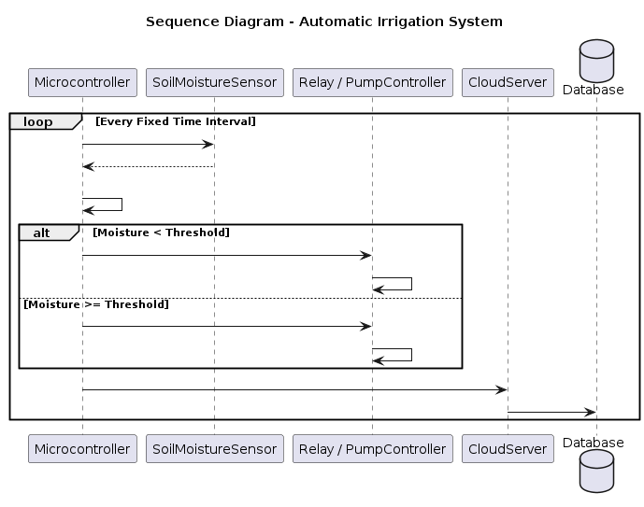
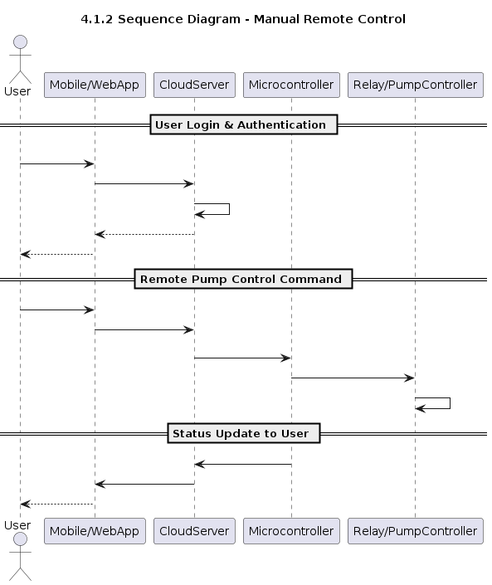

4.2 Data Flow Diagrams (DFD)

DFD(Level 0)
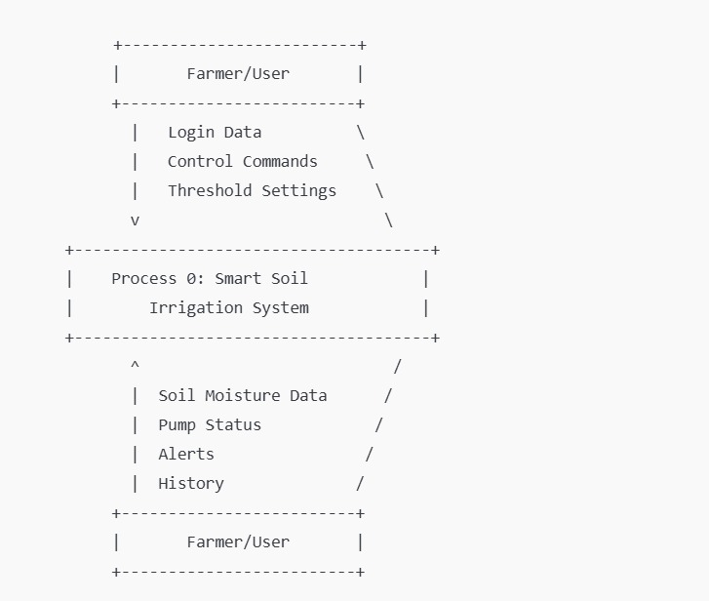

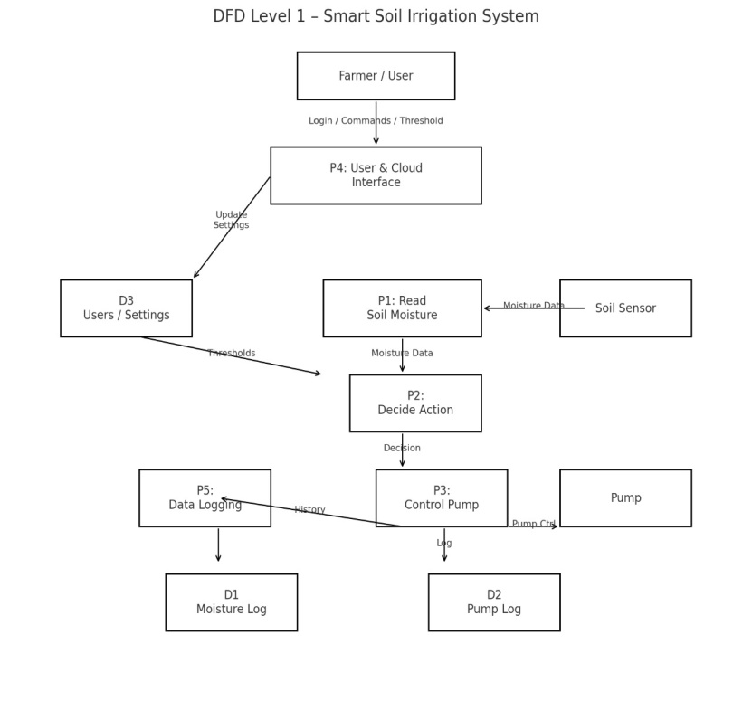

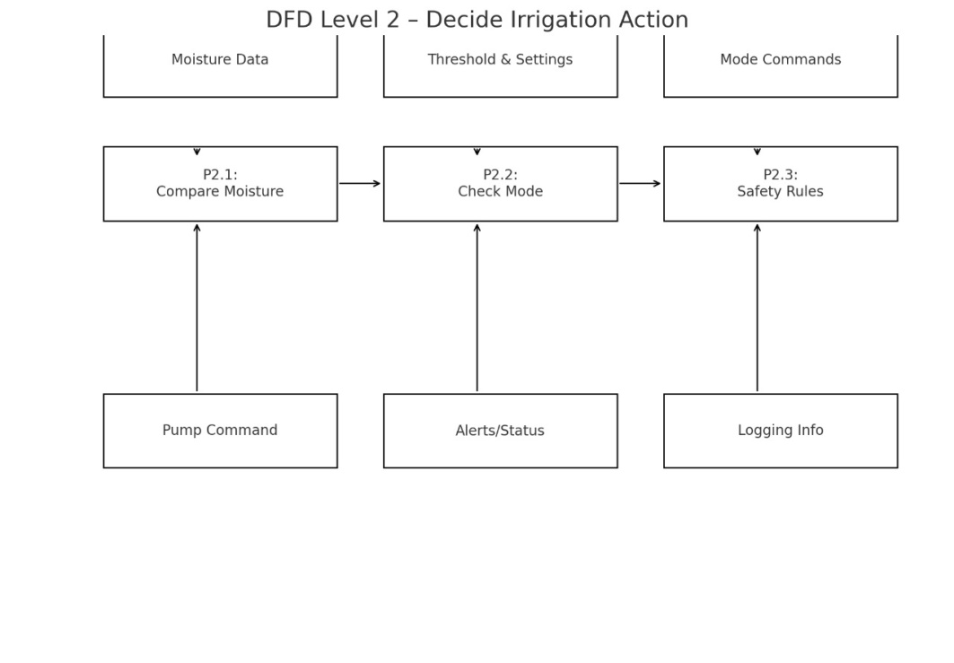
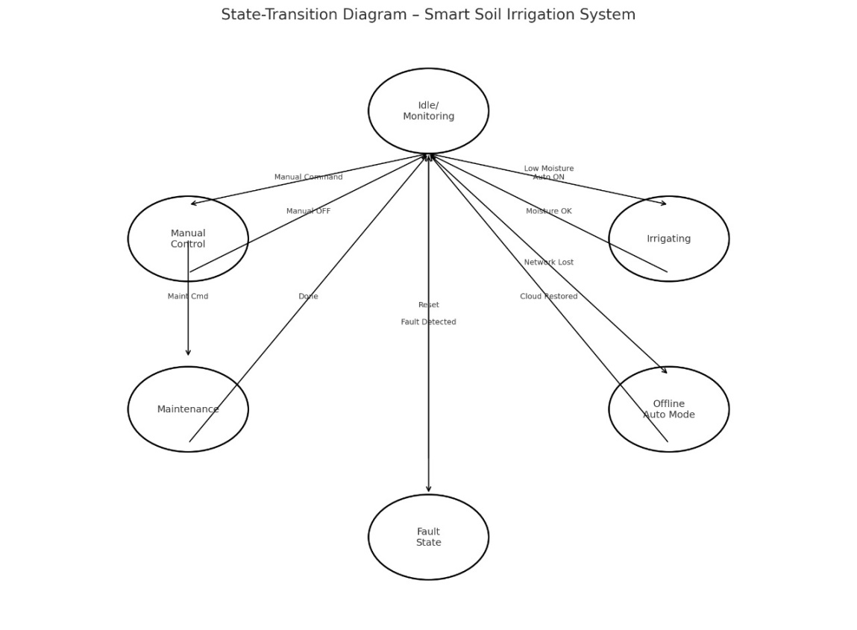

5. Supporting Information

This section contains additional material that supports the development, understanding, and evaluation of the Smart Soil Irrigation System but is not part of the core functional requirements. It may include background research, hardware specifications, formulas, calibration methods, sensor characteristics, and detailed data descriptions.
Supporting information is typically provided in appendices to avoid overloading the main SRS content and to keep the requirement sections focused.

5.1 Purpose of Supporting Information
- To document research that justifies design decisions (for example, choice of sensor type, threshold ranges, microcontroller selection).
- To provide detailed definitions of all data items used in the system (data dictionary).
- To record any formulas or algorithms used (e.g., moisture conversion formula, runtime calculation).
- To give extended descriptions that may be useful for future improvements or maintenance.

5.2 Organization
The supporting information for this project is organized into two main appendices:
- Appendix A – Background Research on Smart Soil Irrigation Systems, Sensors, and IoT
- Appendix B – Data Dictionary (detailed description of each data element used in the system)
These appendices can be expanded as the project progresses.

Appendix A – Background Research on:
This appendix provides a summary of the theoretical and practical research that supports the Smart Soil Irrigation System.
A.1 Smart Irrigation and Water Management
- Importance of precision irrigation in agriculture
- Problems with traditional manual irrigation (over-watering, under-watering, labor-intensive)
- Advantages of automated and sensor-based irrigation:
  - Water saving
  - Balanced soil moisture
  - Enhanced crop productivity
A.2 Soil Moisture Sensors
- Types of sensors:
  - Resistive soil moisture sensors
  - Capacitive soil moisture sensors
- Working principles:
  - How sensor output correlates with soil water content
- Calibration methods:
  - Matching sensor readings with actual soil condition
- Factors that affect sensor accuracy:
  - Soil type (clay/sand/loam)
  - Temperature, salinity, and installation depth
A.3 Microcontrollers and Wireless Communication
- Microcontroller platforms:
  - Arduino, ESP8266, ESP32 and their features
- Why ESP/Arduino platform is suitable:
  - Low power consumption
  - Easy programming (C/C++)
  - Built-in Wi-Fi (in ESP boards)
- Overview of Wi-Fi network use in farms and greenhouses
A.4 IoT Platforms for Remote Monitoring
- Concept of IoT (Internet of Things) in agriculture
- Cloud platforms / dashboards for:
  - Real-time data visualization
  - Remote control
  - Storing historical data
- MQTT/HTTP communication protocols used to send data from device to cloud
A.5 Renewable Energy for Agricultural Automation
- Use of battery and solar panels to power small irrigation controllers
- Benefits:
  - Independent operation in remote locations
  - Reduced electricity bills
- Basic design considerations for solar-powered systems (panel size, battery capacity, charge controller).

Appendix B – Data Dictionary
The Data Dictionary defines and describes each significant data item used in the Smart Soil Irrigation System. It provides name, type, range, description, and where it is used.
B.1 Key Data Elements
Data Name | Type | Range / Example | Description | Used In
moisture_percentage | Integer / Float | 0–100 (%) | Soil water content expressed as percentage | SensorReading, UI, Logic
raw_sensor_value | Integer | 0–1023 (ADC) | Raw ADC value read from sensor pin | Firmware
threshold_value | Integer | 0–100 (%) | Minimum required moisture before irrigation starts | Settings, Logic
pump_state | Enum/String | "ON" / "OFF" | Current status of pump | UI, Logs
mode | Enum/String | "AUTO" / "MANUAL" | System operating mode | Control Logic
alert_status | Boolean | True/False | Indicates if alert is active (e.g., low moisture) | UI Alerts
timestamp | DateTime | e.g., "2025-03-21 10:30:00" | Time at which reading/event occurred | Logs, History
user_id | Integer | Positive | Unique ID of user | User Table
username | String | e.g., "farmer01" | Login identifier | Authentication
password_hash | String | Encrypted string | Hashed password stored securely | Authentication
device_id | String/Int | e.g., "DEV-001" | Unique irrigation system ID | Mapping logs to device
trigger_type | Enum/String | "AUTO" / "MANUAL" | Reason why pump was activated | PumpEvent Table
duration_minutes | Float | ≥ 0 | Time for which pump remained ON | Analysis reports
sensor_status | Enum/String | "OK" / "FAULTY" | Health of sensor based on diagnostics | Fault handling
wifi_signal_strength | Integer | In dBm | Strength of Wi-Fi connection | Diagnostics panel
You can add more entries as you refine your implementation.

